**My Portfolio Website**

**Reynald B. Maglunob**

**3rd Year Bachelor of Science and Computer Science**

**Website Description**

This website is a personal portfolio designed to showcase the academic and professional journey of Reynald B. Maglunob, a third-year Bachelor of Science in Computer Science student at Cainta Catholic College. The portfolio includes sections for academic background, web development projects, and contact information, aiming to connect with visitors and potential collaborators through a clear, well-organized layout.

**Description of Web Pages**

1. **Home Page (index.html)**: Introduces the site and provides a brief introduction, including links to social media and a downloadable resume. This page establishes the main navigation and welcome content, allowing visitors to explore the other sections.
2. **Academic Page (academic.html)**: Contains an overview of academic achievements and projects. It lists academic institutions attended and showcases web development assignments, giving visitors insight into educational and project experience.
3. **About Page (about.html)**: This section would typically describe the individual’s skills, goals, and other personal information, though specifics were not detailed in the code provided.
4. **Contact Page (contact.html)**: Encourages visitor engagement with a contact form and links to social media profiles, enabling networking and collaboration opportunities. It includes an interactive form for sending messages directly from the page.

**Frontend Web Technologies Used**

1. **HTML**: Used for structuring each web page, from headers to content sections and forms.
2. **CSS (with external libraries)**:
   * **Font Awesome**: Adds icons for social media and navigation, enhancing visual appeal and clarity.
   * **AOS (Animate on Scroll)**: Provides smooth animations for elements as they enter the viewport, adding interactivity and visual engagement.
   * **Custom CSS (style.css)**: Applies specific styles across pages for consistent design, ensuring responsiveness across different devices.
3. **JavaScript**: Manages interactive features, such as the mobile navigation hamburger menu and initializing AOS animations for a dynamic user experience.

**URL of the Website**

[**https://maglunob15.github.io/**](https://maglunob15.github.io/)

**Screenshots of Website**

**Home**

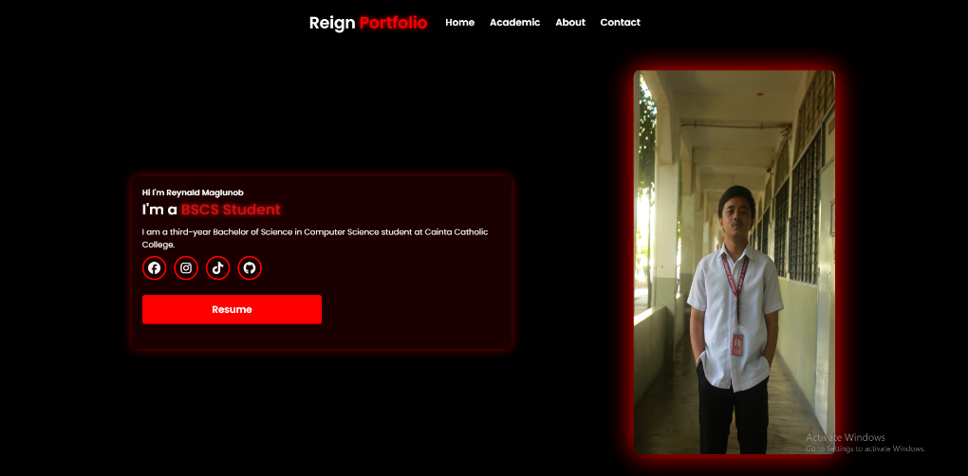

**Academic**

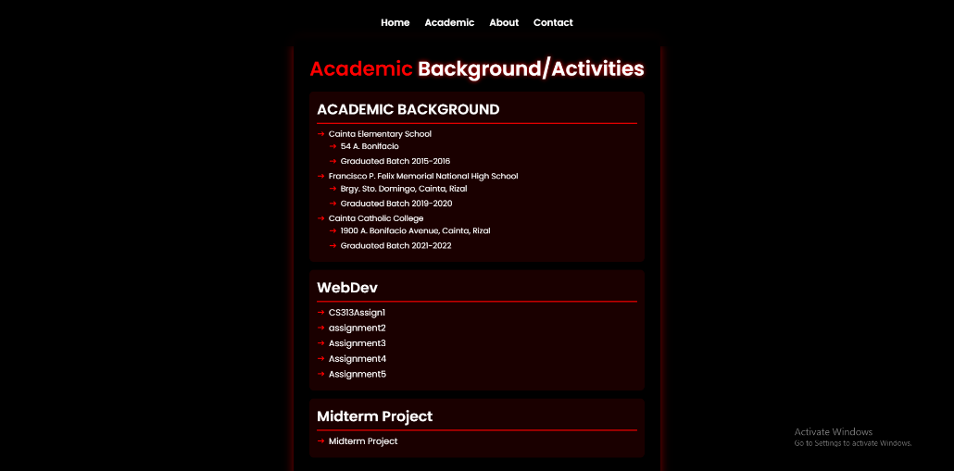

**About**

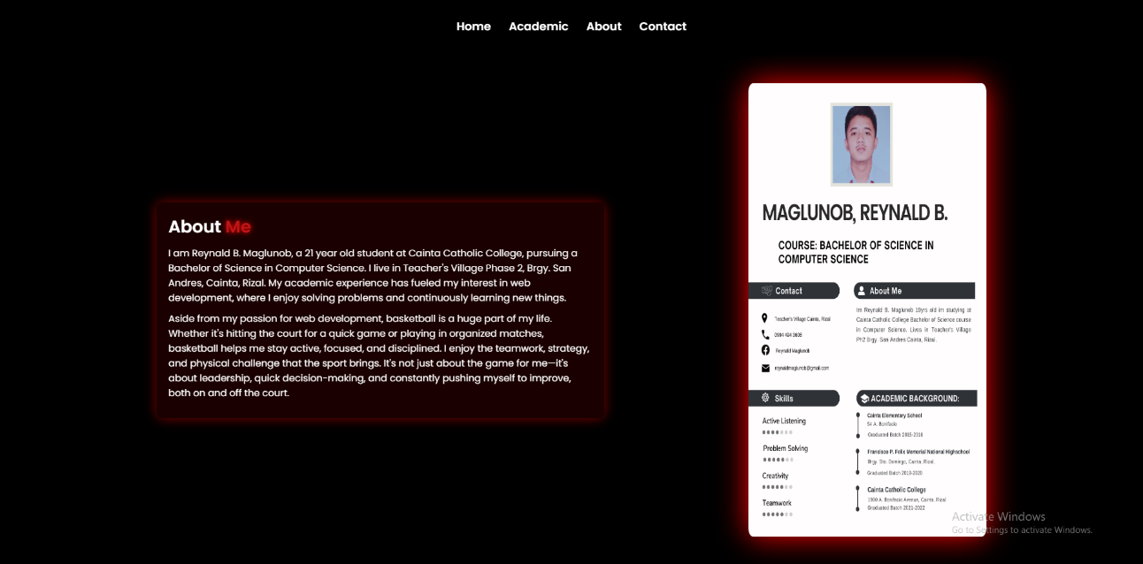

**Contact**

